Copyright Law — Discussion Questions
Matthew Sag
Fall 2026
These are the discussion questions for Copyright Law, Fall 2026, in the order we will take them. You are responsible for reviewing each question before the class it belongs to, and for committing at least a rough answer to writing beforehand. You may be called on at random to begin the discussion. Your answers are not expected to be perfect, simply a good faith effort to engage with the material.

1. Trivial copying?
For Wednesday, August 19 — Chapter 2.
Fred L. Worth was the author of The Complete Unabridged Super Trivia Encyclopedia and The Complete Unabridged Super Trivia Encyclopedia, Volume II. Worth's books are compilations of facts, alphabetically arranged under headings that are followed by explanations of the particular entry. In 1984, Worth, accused the makers of the board game Trivial Pursuit of copyright infringement. Worth claimed that more than a quarter of the questions in the game's Genus Edition had been taken from his books. He noted that typographical errors and deliberately placed misinformation had been copied by the game’s creators. The game’s creators acknowledged that Worth’s books were among their sources.
The following example is representative of the use of Worth's books:
Worth's entry:
Abel, Colonel Rudolf
Russian spy exchanged February 10, 1962 for F. Gary Powers, U–2 pilot.
Game Card
Q. What Russian spy was exchanged for U–2 pilot Gary Powers in 1962?
A. Rudolf Abel.
Worth lost his court case, see Worth v. Selchow & Righter Co., 827 F.2d 569 (9th Cir.1987), but this litigation pre-dates the Supreme Court’s decision in Feist v. Rural Telephone. How would the case be analyzed in light of Feist?

2. Monkey selfie
For Monday, August 24 — Chapter 3.
Applying Feist and Burrow-Giles, consider a photo taken by an untrained monkey who does not realize that he is holding the camera, would that photo be protected by copyright law? Would it make a difference to you if the monkey had been trained to take photos?

3. Superman
For Wednesday, August 26 — Chapter 4.
As an actor, the role of Superman made Christopher Reeve famous and virtually synonymous with superhuman strength and endurance. In 1995 Reeve broke his neck in a horse riding accident and became a quadriplegic. When the actor died in 2004 he was remembered in countless newspaper editorials and cartoons. Consider the following images:
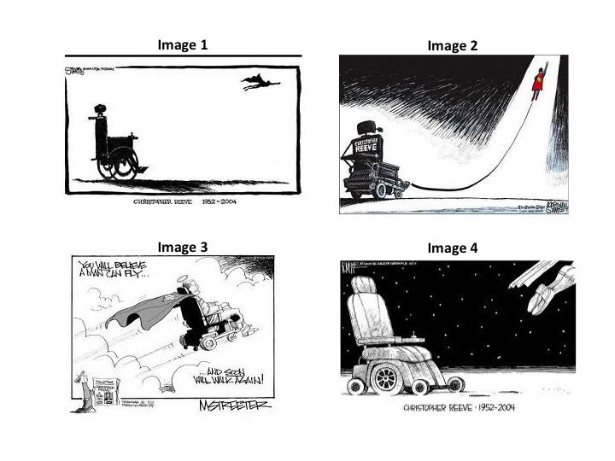
If the author of Image 2 admitted to being influenced by Image 1, would that be enough to establish copyright infringement. If Image 3 and Image 4 were proven to have been created independently of any other image, how would that influence your analysis? How would you draw the line between idea and expression in these images?

4. Sabrina and the rainbow genie
For Wednesday, August 26 and Monday, August 31 — Chapters 4 and 5.
Sabrina develops a series of aesthetically pleasing movement exercises that performed in the right order will summon a genie who will create a rainbow on command as a reward. Sabrina explains the exercises and the proper form and sequence in a book and obtains a copyright registration for the book. Beth learns the sequence and teaches it to her class of budding witches.
Sabrina sues Beth for copyright infringement. Explain all of the reasons why Beth must prevail.

5. Harold The Spy
For Monday, August 31 — Chapter 5.
On 17 December 1967, Harold Holt, the Prime Minister of Australia, disappeared while swimming in the sea near Portsea, Victoria. An enormous search operation was mounted in and around Cheviot Beach where Holt went missing, but his body was never recovered. Historians agree that Holt likely misjudged his own swimming ability and the roughness of the conditions, and was simply overcome by exhaustion. It is also possible that he was attacked by a shark, or a jellyfish, or some other deadly Australian animal.
In 1985, Canadian journalist Tony Baloney published a book explaining his theory that Harold Holt had been a spy for the People’s Republic of China, and that Holt faked his own death to defect to China. Baloney described in detail how Holt was collected by Chinese scuba divers and spirited into a waiting submarine. Baloney’s theories did not win any history prizes, but he sold a lot of books.
Suppose that in 2022, Universal Studios decided to make a film dramatizing the last days of Harold Holt on the premise that Holt was indeed a Chinese spy who faked his own death in the manor Baloney suggested.
Is this copyright infringement?
Would it matter if Tony Baloney said that he made the whole story up just to sell a few books?
* Note that the first two paragraphs of this hypo are based on real events, except that the identity and motivations of the journalist have been changed.

6. Red bus
For Wednesday, September 2 — Chapters 6 and 7.
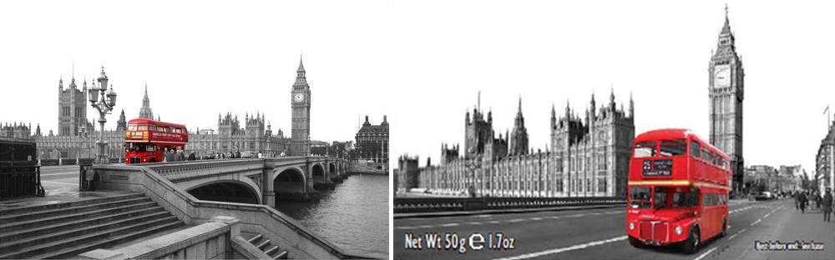
The photo on the left hand side was taken in 2005. The photographer, Mr. Fielder, used Photoshop to recolor the image to make the red bus stand against a black and white background. He was apparently inspired by the film Schindler’s List. The image was also edited to remove the sky and some people. In 2010 another photographer took three photos of the Houses of Parliament and one of a red Routemaster bus to produce the image on the right hand side. The second photographer, Mr. Houghton, licensed his image for use on souvenir tins for tea. Mr. Houghton was aware of the existence of Mr. Fielder’s picture.
Is the Houghton photo an infringing reproduction of the Fielder photo? What test should a court use to determine this?
Is this a case that a district court could resolve on summary judgment, or would it need to go to a jury?

7. The Interview
For Monday, September 14 — Chapters 10 and 11.
The Interview is a 2014 comedy film that depicts the assassination of North Korean leader Kim Jong-un. After a serious incident of computer hacking and vague threats, a number of major North American cinema chains canceled screenings of The Interview in the interest of safety. Sony, the parent company of the film studio, then canceled the theatrical release of The Interview. Illinois Sen. Mark Kirk announced that planned to screen the film at a fundraiser for his re-election campaign “to send a message to North Korea.” Assume that this is a public performance under Section 106(4) of the Copyright Act of 1976. Is this fair use? Briefly explain your answer in relation to each of the fair use factors in Section 107 of the Copyright Act.
Those of you who are unfamiliar with this film and the controversy it caused can find more details on The Interview at https://en.wikipedia.org/wiki/The_Interview.

8. George Floyd Fair Use
For Monday, September 14 — Chapters 10 and 11.

Content Warning
Please note that this discussion question is about art inspired by George Floyd. The facts address the tragic and disturbing details of Mr. Floyd’s murder in 2020 during the Covid-19 Pandemic. I appreciate that this may be a difficult topic for some, but in general, I think it is important for us to be able talk about difficult things.

George Floyd
George Perry Floyd Jr. was an African-American man who was murdered by a police officer in Minneapolis, Minnesota, during an arrest on May 25, 2020. Derek Chauvin, one of four police officers who arrived on the scene, knelt on Floyd’s neck and back for 9 minutes and 29 seconds. The murder of George Floyd sparked protests against police brutality and institutionalized racism across the United States and around the world. George Floyd’s final words “I can't breathe,” became a rallying cry in this cause.
Images, paintings and murals of George Floyd circulated widely after his death. Artists around the world created murals honoring Floyd. The photo of George Floyd in the figure below appears on the George Floyd Wikipedia page, it appears to be a selfie taken from George Floyd’s Facebook page. The second image in the figure below is a mural titled “Icon of a Revolution #1” painted by DAESK (Peyton Scott Russell) in 2020. The mural is 12 feet by 12 feet, Aerosol, Latex on OSB Plywood. (See generally, https://houseofdaskarone.com/)
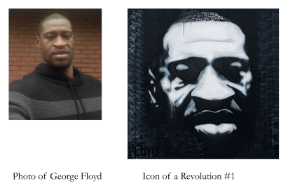
For additional context: Sam Lane, Fred De Sam Lazaro & Dorothy Hastings, “The Artist Behind A George Floyd Mural Reflects On How It Became A ‘Ubiquitous Icon’” PBS NewsHour, May 14, 2021 available at https://www.nwpb.org/2021/05/14/the-artist-behind-a-george-floyd-mural-reflects-on-how-it-became-a-ubiquitous-icon/
Is the Icon of a Revolution mural fair use? Can Mr. Russell license reproductions of his artwork?
How, if at all, does the Supreme Court’s decision in Andy Warhol Foundation for the Visual Arts, Inc. v. Goldsmith impact your analysis?

9. Banksi Collective
For Wednesday, September 30 and Wednesday, October 7 — Chapters 16 and 18.
Jane Banski is a popular artist in her own right and the leader of the Banski Art Street Integrated Collective (BASIC), a loose knit collection of street artists who regularly coordinate their work under Banski's direction. At a group meeting on June 1, last year, Banski instructed her group as follows:
"I want to fling mud in the eye of the military industrial complex! You should each find a warehouse or some other blank space and spray-paint a mural depicting a stern looking soldier with a rifle that fires balloons. The painting should be thickly drawn black and white tones, except for the balloons, which should be colorful with a metallic sheen."
Banski then showed the group a picture of an AR-15 rifle.
Amanda and Brian were members of BASIC who attended the June 1st meeting. Over the next few days Amanda and Brian located a suitable site, obtained the permission of the warehouse owner, Cameron, and set to work on a painting faithful to Banski's instructions. Amanda painted the balloons and the background while Brian painted the soldier and the gun. When the mural was finished, Amanda and Brian signed their names on the bottom left corner of the mural and joined the first letters of their names to "sic" to spell out "BASIC".
In July, Diva & Diva, an advertising agency approached Banski for permission to use the mural in a commercial and Banski agreed, accepting a one-time payment of $10,000 for "the entire copyright interest in said mural." Banski signed the agreement with Diva & Diva, but chose not to inform Amanda and Brian. When Diva & Diva's commercial for the National Rifle Association was broadcast in October, Amanda and Brian were quite upset. So too was Cameron. Cameron wants to paint over the mural because he does not want to be associated with the NRA. Amanda and Brian don’t want their work destroyed, but they do want compensation from Diva & Diva and to stop any further use of what they consider their art to support the NRA. Would it make any difference if Amanda and Brian had trespassed on Cameron’s property and painted their mural on the warehouse without Cameron’s approval?
Discuss.

10. Copyrightable works?
For Monday, October 5 — Chapter 17.
According to the Compendium of U.S. Copyright Office Practices, Third Edition, Chapter 300, will the Copyright Office grant a copyright registration for any of the following:
- pornographic works?
- a character in a novel?
- catchphrases or slogans?
- a DNA sequence?
- blank forms?
- a work authored by a U.S. Government employee within the scope of her employment?
- a pre-existing song transposed from B major to C major?
- skywriting?
Explain your answer.

11. Wave Spoon
For Wednesday, October 14 — Chapter 19.
Omni Consumer Products created a revolutionary new spoon, called the wave spoon. Pictured below. The bowl portion of the spoon is an oval shape. The handle of the spoon curves upward and then downward to mimic a wave design. From an aerial view, the Work forms a “C” shape.
Wave Spoon:
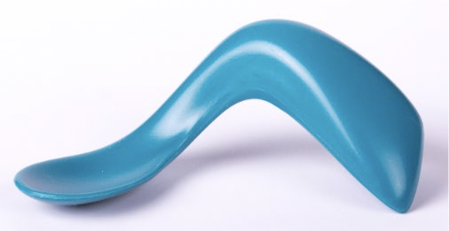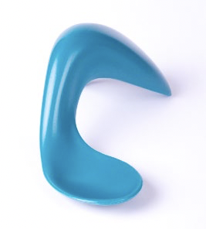
OPC plans to sell the spoons to parents of small children, but it notes that many people don’t see the Wave Spoon as a spoon, but rather as a sculptural work.
OPC believes the spoon is ideal for children, because in addition to its aesthetic appeal, the “shallow bowl signals appropriate portion size bites and supports proper lip closure;” the “thumb depression encourages tripod grip development and provides stability;” the “short wide handle brings the bowl closer to a child’s hands for better control and the”dip & curve of the spoon brings food into the position the child needs.”
Is the OCP Wave Spoon copyrightable if OPC registers it as sculptural work?

12. Zikoff v FitFlix
For Wednesday, October 21 — Chapter 21.
Viktor Zikoff holds a valid copyright in an audiovisual work entitled “Ballet Class Viktor Zikoff” (the “Work”). From 2016-2018 Zikoff sold DVD copies of the Work, but in late 2018 Zikoff switched to a streaming model. Zikoff’s DVDs were all stamped as “not for rental.”
FitFlix LLC runs a web-based business that rents physical copies of fitness and dance DVDs by shipping the DVDs to its customers. Once the customer has finished using the DVD, the customer returns it, and FitFlix sends the customer the next DVD on that customer's personally selected queue of DVDs.
FitFlix’s records indicate from 2018 to 2021 it rented out a DVD of the work 17 times, before the disc (“Disc 1”) was lost by a customer in May 2021. FitFlix has no records that indicate where it purchased Disc 1. In June 2022, FitFlix purchased a new copy of the work on DVD from an online retailer South Korean in 2021(“Disc 2”). The production stamp on Disc 2 indicates that it was made in China. Zikoff asserts that he never authorized anyone in China to reproduce his DVDs.
Disc 2 was offered for rental by FitFlix from 2021 to 2022, but was never actually rented.
On May 15, 2022, Zikoff brought suit against FitFlix, asserting claims for copyright infringement.
Will Zikoff prevail? Explain your answer.

13. Wombat Streaming Device
For Monday, November 2 — Chapter 23.

Wombat
Wombat LLC has invented a new generation of streaming media technology. The Wombat is a hardware device that connects a consumer’s cable television signal to the internet. Here is how it works:
Step One: The Wombat accepts a standard video signal from a standard cable box via an HDMI connection because it has been programed with encryption keys to respond to the HDCP (High-bandwidth Digital Content Protection) DRM that standard cable boxes use to talk to standard televisions. Basically, the Wombat tells the cable box, “I’m a TV you can trust, here is the secret handshake that proves it.” Wombat LLC is not an authorized licensee of the HDCP encryption keys, it obtained them from an unknown person who reverse engineered the keys.
Step Two: The Wombat stores the video signals it receives in 30 second chunks. Once a given 30 second chink has been recorded, the Wombat encodes the chunk into a different format for transmission over the Internet to a remote device specified by the user—this process is called “transcoding.” The transcoding process takes about 15 seconds. As soon as the transcoding is complete, the original 30 second chunk is deleted and the transcoded chunk is then transmitted to the user and deleted.
The basic operation of the Wombat is illustrated below.
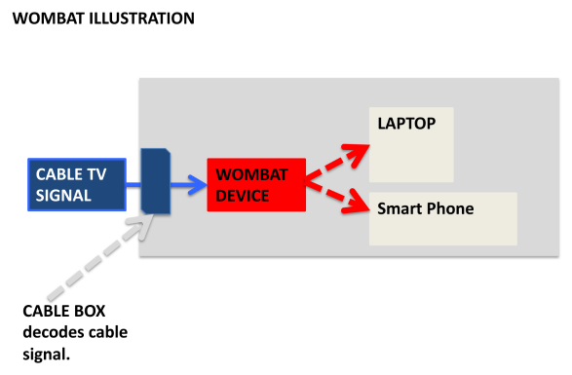
Wombat LLC sellS Wombat devices to consumers who want to watch their local cable channels when they are traveling interstate or out of the home.
Setting aside questions of fair use, and assuming they do not have permission, are Wombat users who use the device to watch cable television on their personal phones and laptops infringing the public performance right? Is Wombat LLC infringing the public performance right?

14. Super-Share
For Wednesday, November 4 and Monday, November 9 — Chapters 24 and 25.
Super-Share is an online storage locker where users can upload any type of file. Once a file is uploaded, Super-Share generates a URL that can be used to download the file. The service is free to use because Super-Share makes its money through advertising. Super-Share rewards users whose files are downloaded frequently with super-points that are convertible to cash. Super-Share responds to DMCA takedown requests when it receives them, but does not filter or otherwise proactively look for infringing content. Super-Share is used to store many different file types, but the vast majority of files are copyrighted music, film and television that were uploaded without the authorization of the copyright owner.

Question 1:
Assuming that Super-Share does not qualify for any of the DMCA safe harbors, is Super-Share liable for the copyright infringements of its users?

Question 2:
Would Super-Share qualify for any of the DMCA safe harbors?

15. Amanda Whitehat
For Wednesday, November 11 — Chapter 26.
Amanda Whitehat is an art dealer and a part time computer programmer. After learning of a series of art thefts and hearing rumors that the stolen works were often on display in the homes of the rich, Amanda decided to use her programming skills for good. She designed a program to bypass the password requirement for the private social network RichBook (like Facebook, but only for rich people) and match a digital fingerprint of each image to the digital fingerprints of several stolen artworks.
Amanda then reported this information to the police and to the true owners of stolen art. In her reports, she included copies of the matched photos from RichBook and copies of the museum photos of the stolen works. Amanda noticed that some of the photos she planned to send had copyright notices and she was concerned that this might cause problems. So, before she sent the photos to the police and to the true owners of stolen art, she cropped out the copyright notices.
Allen Allenson is a hedge fund manager who was forced to return stolen art that had been identified by Amanda. Allen wants revenge against Amanda and plans to sue her for copyright infringement, violating the anticircumvention provisions and the CMI of the DMCA.
Advise Amanda. Do not address liability for computer hacking under the CFAA and similar statutes or equivalent common law arguments.

16. XOVision
For Monday, November 16 — Chapter 27.
XOVision is a cable service provider that offers its subscribers a remote digital video recorder similar to the one litigated in the Cablevision case in the Second Circuit. XOVision is different, however, in that it uses a special algorithm to determine additional programs that individual subscribers might like to watch and it automatically records those programs as well. One program the XOVision R-DVR often records for subscribers is The Adventures of Super Person.
Setting aside the issue of fair use, if the copyright owner of The Adventures of Super Person sued XOVision for copyright infringement, would it be able to show that XOVision was directly liable for violating the reproduction right?
How if at all would your answer change if XOVision sold DVRs direct to the consumer for home use, but still used it’s special algorithm to determine additional programs that the users might like to watch such that the DVRs would automatically record those programs?

17. Bunny torture lawyer downfall photo
For Monday, November 16 — Chapter 27.
On February 27, 2008, Ava Armstrong was working as a junior lawyer for Evil & Associates. On that fateful day, Ava was tasked to accompany the firm’s managing partner, Bob Evil, to the state Supreme Court to argue for the constitutional rights of a man accused of animal cruelty toward rabbits. As the two lawyers climbed the courthouse steps, Ava tripped and sent a large box of documents spilling down the stairs.
Sofia, a professional photographer, captured the incident in a vivid photo showing Ava lying on the steps reaching for documents as Bob Evil, face turned bright red, screams at her. The photo (known as the “Bunny Torture Lawyer Downfall” photo because of the news headlines that accompanied it) and the incident are mildly famous and the photo has been used as meme with labels placed on Ava, Bob and the empty document box for humorous effect.
Sofia registered her copyright in the photo in March 2008 and has licensed it in a number of contexts over the years. Sofia has sued several organizations for their unauthorized reproduction of the photo.
Ava left the Evil firm soon after the Bunny torture lawyer downfall incident and forged a successful career in civil litigation. Last week, Ave was appointed to be a federal district judge and she posted the news to Instagram along with the Bunny Torture Lawyer Downfall photo. In her post she noted how far she had come from that fateful day.
Several online news services posted stories about Ava’s career and the novelty of a judge announcing her appointment on Instagram. The Beacon illustrated its story by embedding Ava original post (image plus text) as an image. Riverside Post illustrated its story by embedding a high-quality version of the original photo from Sofia’s own website. Halcyon News did not illustrate its story, but it did link to a website where users could buy unlicensed reprints of the Bunny Torture Lawyer Downfall photo as posters, tee-shirts and coffee mugs.
Are any of The Beacon, Riverside Post, or Halcyon News liable for copyright infringement?

Think of a digital fingerprint as a mathematical abstraction based on work. You can’t reverse engineer and expressive work from its digital fingerprint, but when the digital fingerprints of two works match, it is very likely that the works themselves are a match.

